90

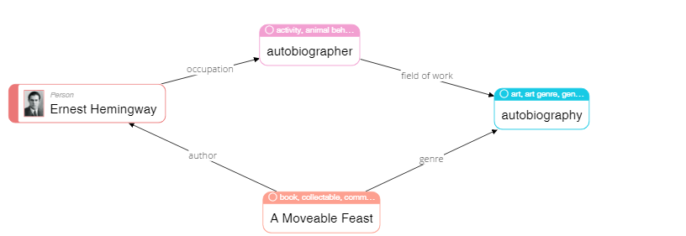

|  |
| --- |
| **Please describe shortly what you see on this diagram? Pay attention only to that information that is understandable or has sense for you.** |
| Ernest Hemingway by A Moveable Feast. A Moveable Feast refers to the genre of autobiography. The autobiographer is the area of interest of the author. |

68

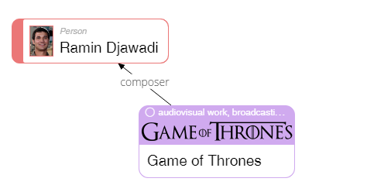

|  |
| --- |
| **Please describe shortly what you see on this diagram? Pay attention only to that information that is understandable or has sense for you.** |
| Ramin Djawadi composer Game of Thrones. |

23

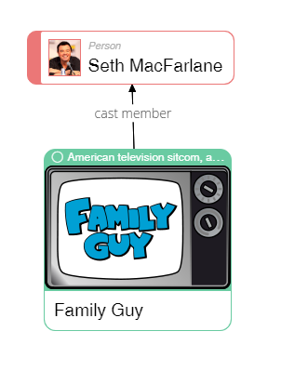

|  |
| --- |
| **Please describe shortly what you see on this diagram? Pay attention only to that information that is understandable or has sense for you.** |
| Seth MacFarlane is the host of the Family Guy program. |

50

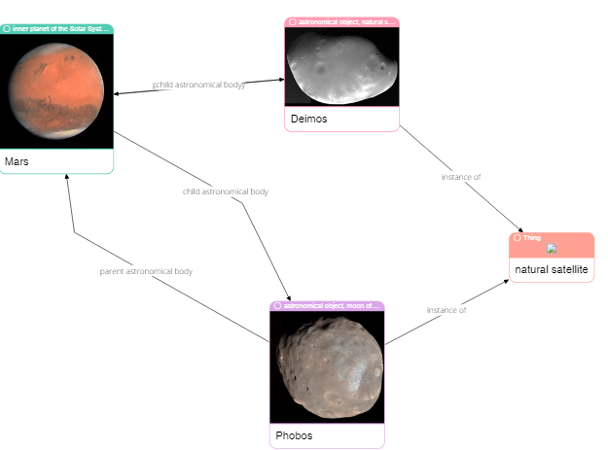

|  |
| --- |
| **Please describe shortly what you see on this diagram? Pay attention only to that information that is understandable or has sense for you.** |
| The satellites of Mars Deimos and Phobos are depicted. |

62

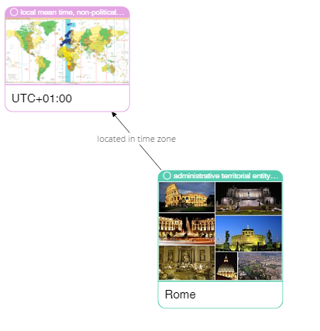

|  |
| --- |
| **Please describe shortly what you see on this diagram? Pay attention only to that information that is understandable or has sense for you.** |
| The time zone of Rome is indicated. Photos of the city are given. |

75

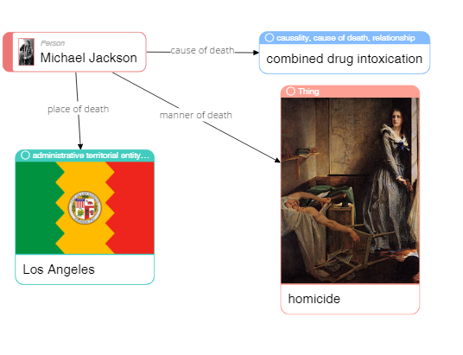

|  |
| --- |
| **Please describe shortly what you see on this diagram? Pay attention only to that information that is understandable or has sense for you.** |
| Indicated where and why Michael Jackson died. |

79

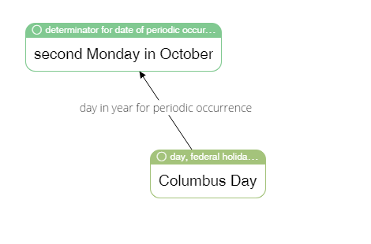

|  |
| --- |
| **Please describe shortly what you see on this diagram? Pay attention only to that information that is understandable or has sense for you.** |
| On the first Monday of October, Columbus Day is celebrated. |

65



|  |
| --- |
| **Please describe shortly what you see on this diagram? Pay attention only to that information that is understandable or has sense for you.** |
| Ole Kirk Christiansen is the creator of the Lego. He began his career in the role of carpenter, carpenter, then became an entrepreneur. |

4

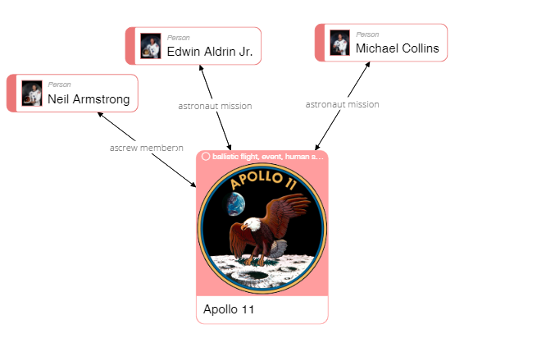

|  |
| --- |
| **Please describe shortly what you see on this diagram? Pay attention only to that information that is understandable or has sense for you.** |
| All these people are connected with the spacecraft Apollo 11. Two astronauts. |

40

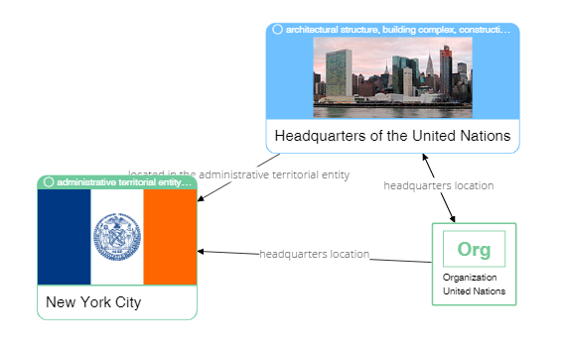

|  |
| --- |
| **Please describe shortly what you see on this diagram? Pay attention only to that information that is understandable or has sense for you.** |
| Organization UN cooperation with the administration of the city of New York. The city administration in turn, interacts with headquarters UN. The headquarters UN of organization UN interacts and the city administration. |

37



|  |
| --- |
| **Please describe shortly what you see on this diagram? Pay attention only to that information that is understandable or has sense for you.** |
| FC Porto is located in Porto. A stadium that has some set of properties and interacts with FC Porto |